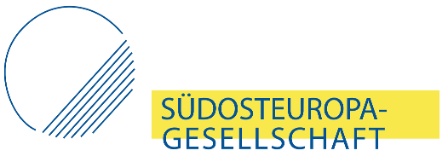
Award for Journalists from Southeast Europe (Solidarity Award)
The Award for Journalists from Southeast Europe is dedicated to those who engage in critical and courageous reporting in the region and thereby make an essential contribution to democracy, rule of law and press freedom in their countries. The award is meant to shield the laureates from threats through the increased attention for their work, and to offer an acknowledgement for the value of their reporting. The Southeast Europe Association shows with this award again that it supports those in the region who stand up for European Values and media freedom. The award ceremony will be held for the first time in Summer 2020 in Berlin. The award complements the Association’s other award for excellent journalism on the region in German media.
Please fill out the entire form (* fields are mandatory) and return it in PDF format to: info@sogde.org We invite everyone to hand in suggestions for awardees. Deadline for proposals is 31 March 2020.
Proponent
*Name, Title
*E-Mail
Job/Position
SOG member

I would like to propose the following journalist from Southeast Europe for the award:
Proposed awardee
*Name, title
Address
(City, country, e-mail, website, social media)
*Institution
(Media outlet, association, etc.)
Occupational status (Permanent, Freelancer, etc.)
*CV
*Work samples
(please fill in links to articles or attach scans)
Further materials
(e.g. links to reports on the person, his or her work, etc.)

*Detailed statement of support (text, max. 1 page):
Please elaborate on why you consider the person a suitable candidate for the award. Focus especially on quality of work, position in national media landscape, extraordinary merits, important topics dealt with, relations to national politics, if applicable threats resulting from work, financial situation, potential benefits from receiving the award.

